1. Conceptual Model

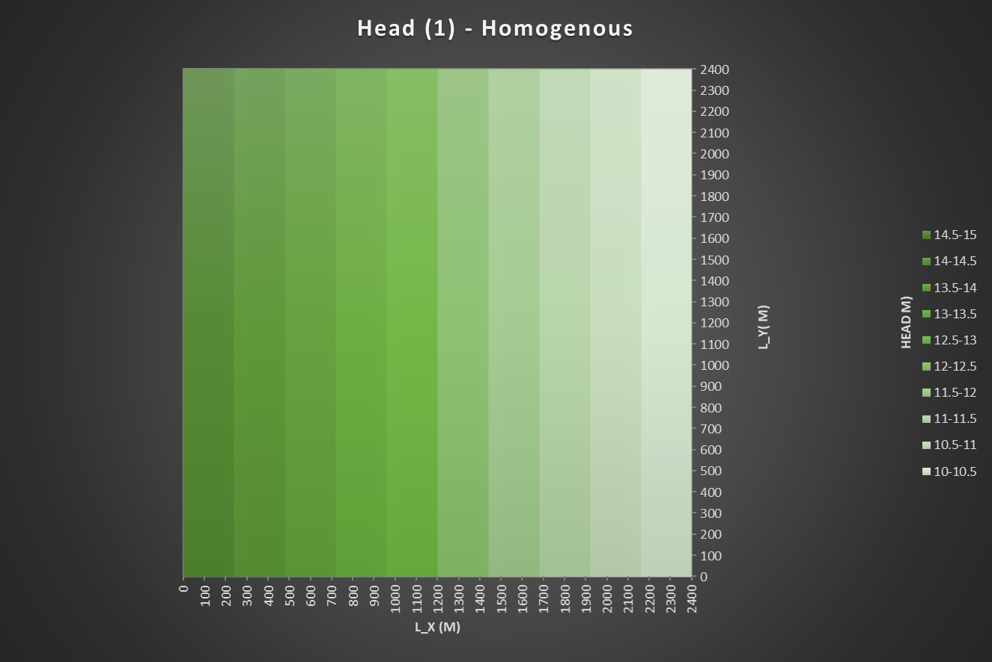

HOmogeneous

Homogeneous

